**Name:** Kiran Komati

**Course:** DSC640

**Date:**09/23/2022

**Tableu - Line Chart:**

**Tableu - Step Chart:**

**R - Line Chart:**

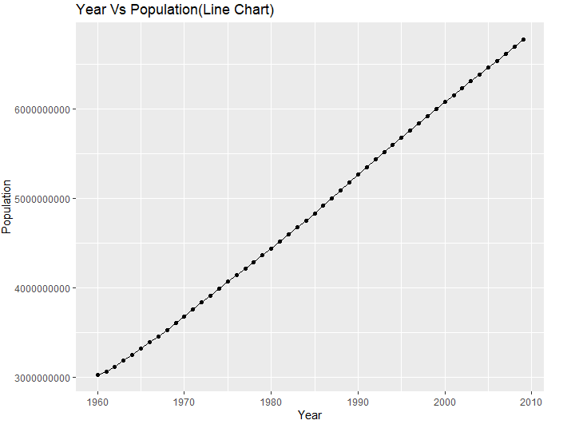

**R - Step Chart:**

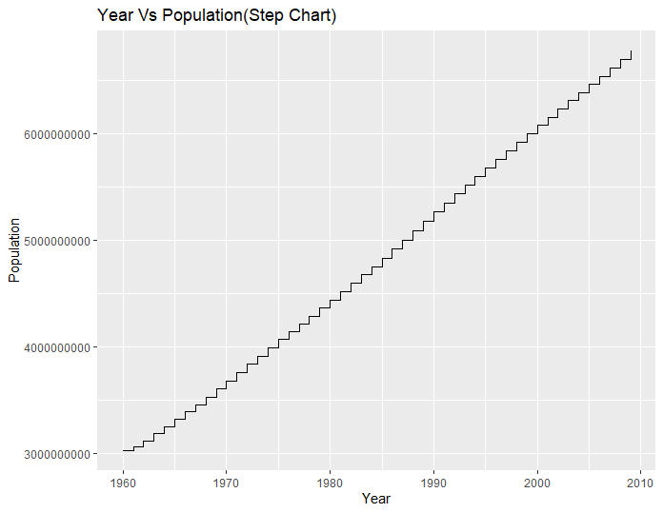

**Python - Line Chart:**

**Python - Step Chart:**

